SEG Awards Level 2

Motor Vehicle Studies

Underpinning Knowledge Evidence Record

H/501/7005 Health and Safety for Motor Vehicle Studies

(Level 1)

Learners Name
SEG Awards Registration Number
Centre Name
Assessor 1 Name
Assessor 2 Name

DECLARATION OF AUTHENTICITY

This declaration must be completed and signed by the learner and countersigned by the tutor / assessor and covers all evidence submitted for moderation.

Learner Name
Unique Learner Number (ULN) |  | SEG  Learner Reg. ID
Qualification Title
Centre Name

Learner statement of authenticity

Before signing please read the guidance below.

I confirm, that the attached assignment / portfolio is all my own work and does not include any work completed by anyone other than myself. I have completed the assignment / portfolio in accordance with SEG Awards’ instructions and within the time limits set by my centre.

Signature |  | Date

Centre confirmation of authenticity

On behalf of …………………………………….(insert centre name), I confirm that the above mentioned learner, to the best of my knowledge, is the sole author of the completed assignment / portfolio attached, and the assessments have been completed under the required conditions.

Signed |  | Date
Name
Title

Guidance for Learners

You have been asked to sign this Declaration of Authenticity and place it at the front of your portfolio or course work assessment. It confirms that the work you have submitted for assessment is your own and that you have not copied it from someone else or allowed another learner to copy it from you.

When preparing any course work it is good practice to undertake research using information from published sources. If you quote directly from these sources then this must be indicated in your work by using quotation marks and referencing the document from which the quotation was taken. You must then comment in your own words on any ideas expressed.

Assessors, internal verifiers and SEG Awards’ external moderators and verifiers are subject specialists who can spot the use of published materials that may be passed as your own words or ideas.
If you do copy words from a published source and do not indicate their reference you will be committing plagiarism. This is considered a form of cheating and may result in your assessment being declared void.
Contents

Task No | Title | Assessment Criteria
1 | Identify workshop equipment | Assessment Criteria 5.2
2 | Emergency evacuation procedure | Assessment Criteria 5.3
3 | Identify fire extinguishers | Assessment Criteria 5.2
4 | Principles of fire prevention | Assessment Criteria 5.1
5 | Identify workshop equipment | Assessment Criteria 3.1, 3.2

NB: Assessment Criteria 1.1, 1.2, 1.3, 2.1, 4.1, 4.2 to be evidenced through the completion of the Job Card for unit K/601/6027 in the Practical Evidence Record for the specified pathway.

Task 1 - Identify Workshop Equipment | Assessment Criteria 5.2

Learner Instructions

- Draw a plan of the workshop in the space below.
- On the plan identify the following
  - Entrances and exits
  - Emergency exit
  - Vehicle lifts
  - Positions and types of fire extinguishers
  - Washing facilities

Assessor Checklist | Achieved  Y/N
Plan is accurate
All items included

Assessor Declaration
In signing this sheet the assessor and learner confirm that all the operations in this task were carried out by the named learner and the learner observed safe working practices at all times.
Assessor Signature……………………………………………………...........Date………………

Learner Signature ………………………………………………………..……Date……………….

Task 2 – Emergency Evacuation Procedure | Assessment Criteria 5.3

Learner Instructions

Every workplace will have an emergency evacuation procedure and it is important that you know the correct procedure for your workshop.
- By inspecting the notices in the workshop, or other means, outline below what you should do in the case of an emergency evacuation
------------------------------------------------------------------------------------------------------------------------------------------------------------------------------------------------------------------------------------------------------------------------------------------------------------------------------------------------------------------------------------------------------------------------------------------------------------------------------------------------------------------------------------------------------------------------------------------------------------------------------------------------------------------------------------------------------------------------------------------------------------------------------------------------------------------------------------------------------------------------------------------------------------------------------------------------------------------------------------------------------------------------------------------------------------------------------------------------------------------------------------------------------------------------------------------------------------------------------------------------------------------------------------------------------------------------------------------------------------------------------------------------------------------------------------------------------------------------------------------------------------------------------------------------------------------------------------------------------------------------------------------------------------------------------------------------------------------------------------------------------------------------------------------------------------------------------------------------------------------------------------------------------------------------------

Assessor Checklist | Achieved  Y/N
Procedure is accurate
All items included

Assessor Declaration
In signing this sheet the assessor and learner confirm that all the operations in this task were carried out by the named learner and the learner observed safe working practices at all times.

Assessor Signature……………………………………………………............Date………………

Learner Signature ………………………………………………………..…….Date………………

Task 3 - Identify Fire Extinguishers | Assessment Criteria 5.2

Learner Instructions
In Task: 1.1, you identified the positions of the fire extinguishers in your workshop, but all extinguishers are not the same and are made for different types of fire.
- Investigate the fire extinguishers in your workshop and complete the diagram below by indicating the type of extinguisher suitable for each type of fire.
The first one has been completed to help you
TYPE OF FIRE | 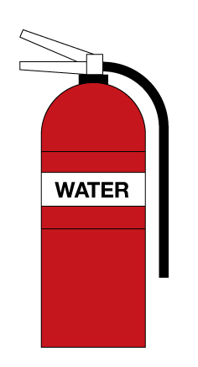 | 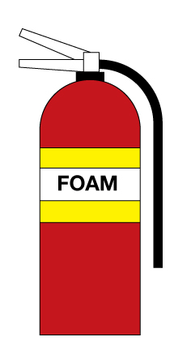 | 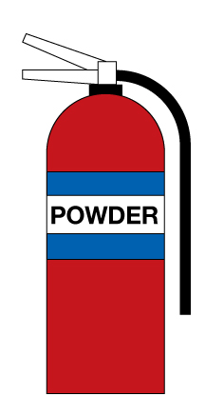 | 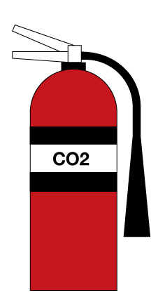
Type A
Paper, Wood, Textile and Fabric
Type B
Flammable Liquids
Type C
Flammable gases
Type E
Electrical Equipment

Assessor Checklist | Achieved  Y/N
Correct extinguishers identified
All items included

Assessor Declaration
In signing this sheet the assessor and learner confirm that all the operations in this task were carried out by the named learner and the learner observed safe working practices at all times.

Assessor Signature……………………………………………………...........Date………………

Learner Signature ………………………………………………………..……Date………………

Task 4 - Principles of fire prevention | Assessment Criteria 5.1

Learner Instructions
The best way of dealing with a fire in the workshop is to prevent it occurring in the first place
In your workshop there will be many steps taken to help reduce the risk of fires.
- By looking around the workshop list FIVE steps that have been taken to reduce the risk of fire.

  - ___________________________________________________________________
  - ___________________________________________________________________
  - ___________________________________________________________________
  - ___________________________________________________________________
  - ___________________________________________________________________

Assessor Checklist | Achieved  Y/N
5 items identified

Assessor Declaration
In signing this sheet the assessor and learner confirm that all the operations in this task were carried out by the named learner and the learner observed safe working practices at all times.

Assessor Signature……………………………………………………...........Date………………

Learner Signature ……………………………………………………………..Date……………

Task 5 - Identify Workshop Equipment | Assessment Criteria 3.1 & 3.2

Learner Instructions

The Control of Substances Hazardous to Health (COSHH) Regulations identifies chemicals that may be hazardous to health.
Many of these substances are used regularly in Motor Vehicle workshops and it is important that we know the risks involved.
The chemicals may also be a risk to the environment if not disposed of properly and so we must know the correct method of waste disposal.
The table below identifies some hazardous substances that are commonly used in Motor Vehicle Repair.
- Complete the table by identifying the risk involved and the method of correct disposal.
Substance | Risk | Disposal
Petrol
Antifreeze
Used Engine Oil
Oil and Fuel Filters
Grease
Brake Fluid

Assessor Checklist | Achieved  Y/N
Risks identified
Correct Disposal

Assessor Declaration
In signing this sheet the assessor and learner confirm that all the operations in this task were carried out by the named learner and the learner observed safe working practices at all times.

Assessor Signature……………………………………………………..........Date………………

Learner Signature ………………………………………………………..…Date………………..

Unless otherwise stated e.g. for some entry level qualifications, learners can work together but should identify sections which are their own work.

